Introduction to ggplot2
STA 418/518 - Statistical Computing and Graphics with R
Andrew DiLernia

Learning Objectives
- Understand the code structure for ggplot plots
- Understand layers of ggplot objects
- Adding labels and captions of ggplot objects
- Understand aesthetics of ggplot objects
- Know the difference between mapping & setting aesthetics
This activity was adapted from Introduction to ggplot2 by Dr. Lucy D’Agostino McGowan.
➡️ First, create a new Quarto document with File > New File > Quarto Document… Render it by clicking the Render button (top left).
- Render it by using the appropriate keyboard shortcut (Mac: Command + Shift + K, Windows: Ctrl + Shift + K).
- Load packages necessary for this activity using the code below. Note: you may need to install packages beforehand by using the install.packages() function and the package name in quotes.
library(palmerpenguins)
library(tidyverse)
library(skimr)
library(knitr)

The ggplot2 package
- The ggplot2 package is one of the most popular data visualization packages among R programmers.
- Created by Hadley Whickham, ggplot2 is one of the many packages making up the tidyverse collection of packages.
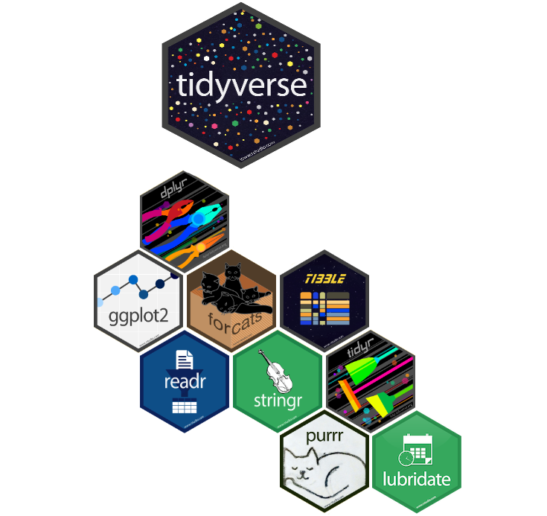

Structure of code
The structure of the code for ggplot2 objects is of the form:
ggplot(data = [dataset],
mapping = aes(x = [x-variable],
y = [y-variable])) +
geom_xxx() +
other options
where
- [dataset] is replaced with a data frame or tibble object
- [x-variable] and [y-variable] are replaced with the names of variables from [dataset]
- geom_xxx() specifies the desired geometry for the ggplot2 object, e.g., geom_histogram() for a histogram or geom_boxplot() for a boxplot.

Example: Palmer Penguins data
The Palmer Penguins data set contains data on 344 penguins from 3 islands in Palmer Archipelago, Antarctica. Specifically, data were collected and made available by Dr. Kristen Gorman and the Palmer Station, Antarctica Long Term Ecological Research Network.
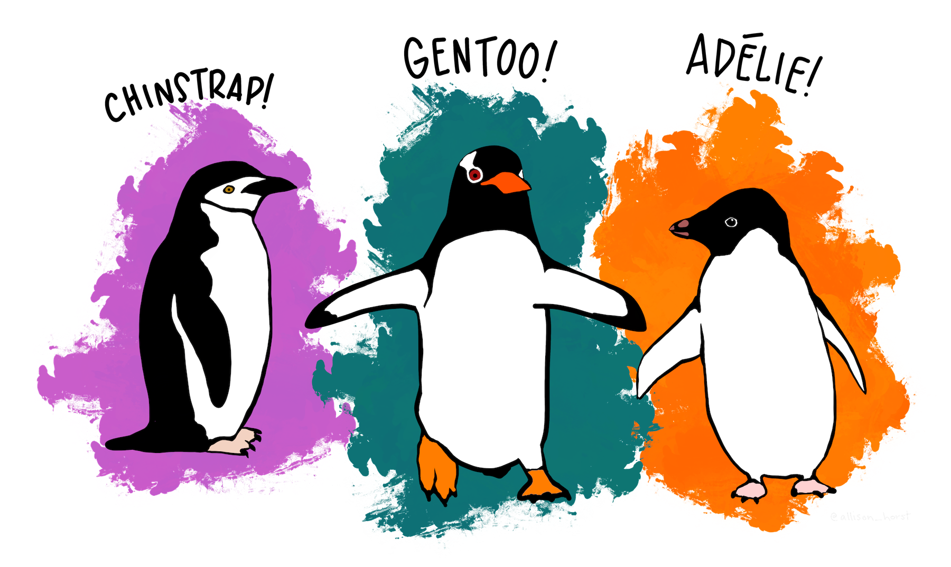 | 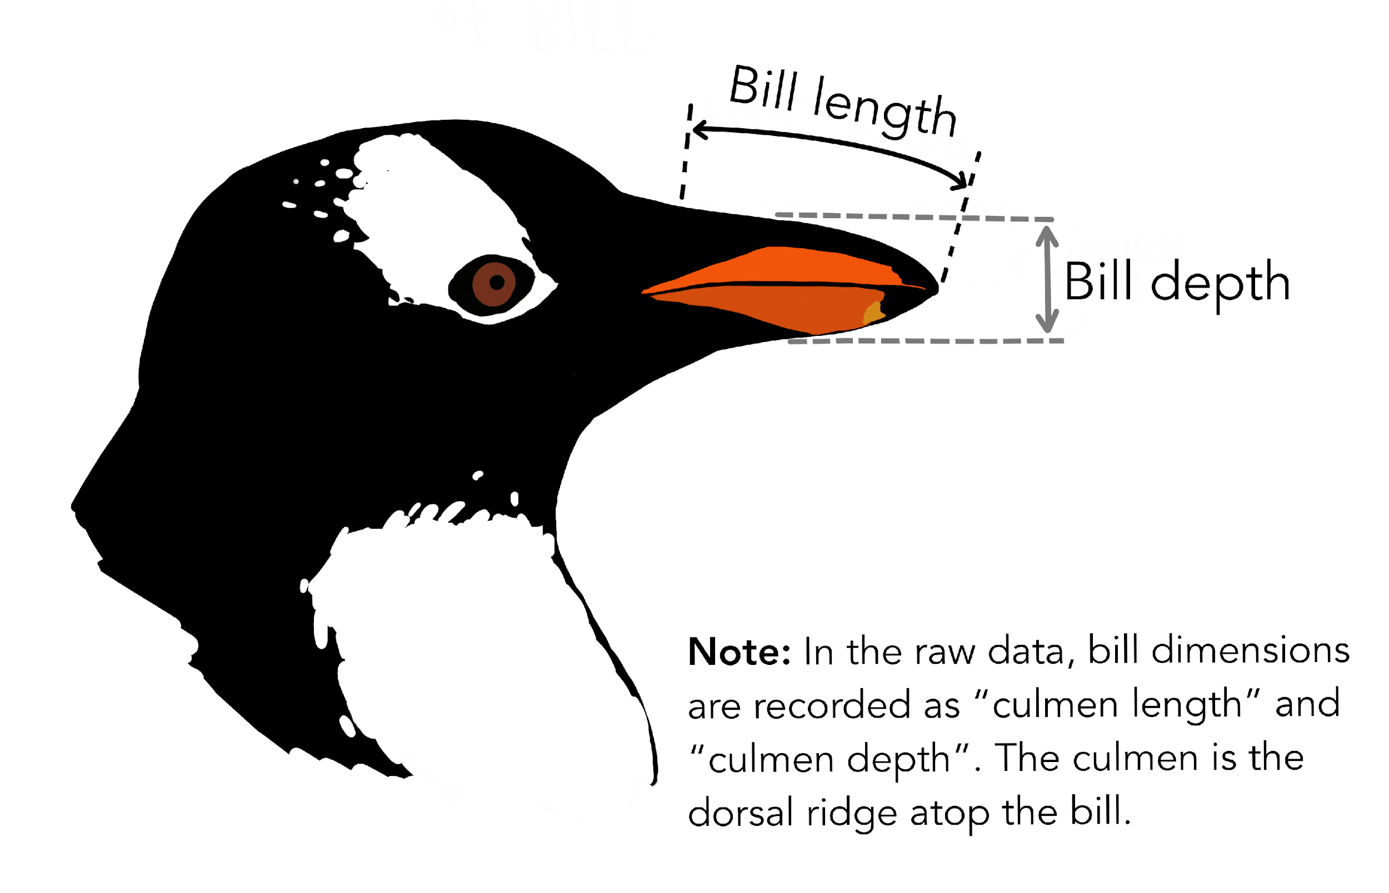
Artwork by @allison_horst
Variable | Description
species | Species of the penguin
island | Island the penguin was found on
bill_length_mm | Bill length (mm)
bill_depth_mm | Bill depth (mm)
flipper_length_mm | Flipper length (mm)
body_mass_g | Body mass (g)
sex | Sex of the penguin
year | Year data was collected
Artwork by @allison_horst
➡️ First, let’s load the Palmer Penguins data set and explore some high-level characteristics of the data set using the code below:
data(penguins, package = "palmerpenguins")
glimpse(penguins)
Rows: 344
Columns: 8
$ species <fct> Adelie, Adelie, Adelie, Adelie, Adelie, Adelie, Adel…
$ island <fct> Torgersen, Torgersen, Torgersen, Torgersen, Torgerse…
$ bill_length_mm <dbl> 39.1, 39.5, 40.3, NA, 36.7, 39.3, 38.9, 39.2, 34.1, …
$ bill_depth_mm <dbl> 18.7, 17.4, 18.0, NA, 19.3, 20.6, 17.8, 19.6, 18.1, …
$ flipper_length_mm <int> 181, 186, 195, NA, 193, 190, 181, 195, 193, 190, 186…
$ body_mass_g <int> 3750, 3800, 3250, NA, 3450, 3650, 3625, 4675, 3475, …
$ sex <fct> male, female, female, NA, female, male, female, male…
$ year <int> 2007, 2007, 2007, 2007, 2007, 2007, 2007, 2007, 2007…
Next, let’s visualize the relationship between the bill depth of the penguins (mm) and the bill lengths (mm) of the penguins.
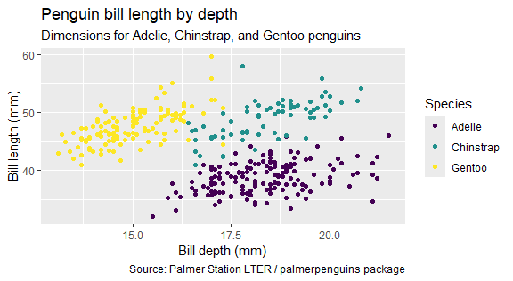

Plot in layers
We will recreate the scatter plot above, building the plot layer by layer. For each new addition, duplicate and modify existing code chunks to create new code chunks.
➡️ Start by creating a blank canvas using the penguins data frame.

➡️ Then, in a new code chunk map bill depth to the x-axis.
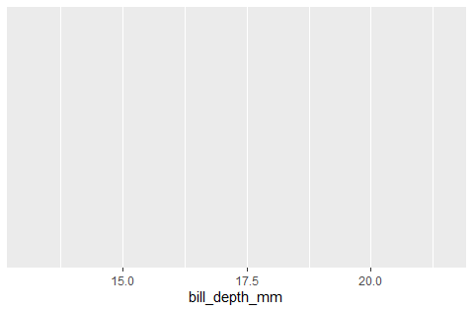
➡️ Next, in another new code chunk, add bill length to the y-axis.
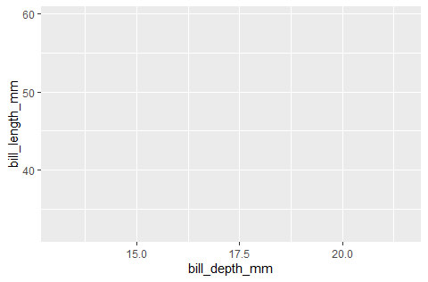
➡️ Create a scatter plot, representing each two-dimensional observation with a point by adding a geom_point() layer. Additional layers are added to a ggplot using the + operator.
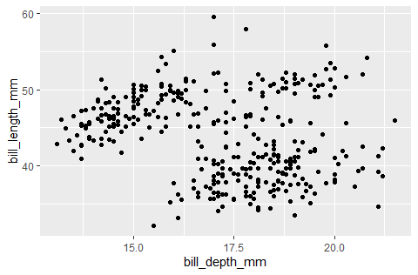

Aesthetics
We can use aesthetics in data visualizations to differentiate between subgroups or to show additional dimensions of the data. Commonly used characteristics mapped to a variable include:
- color
- shape
- size
- alpha (transparency)
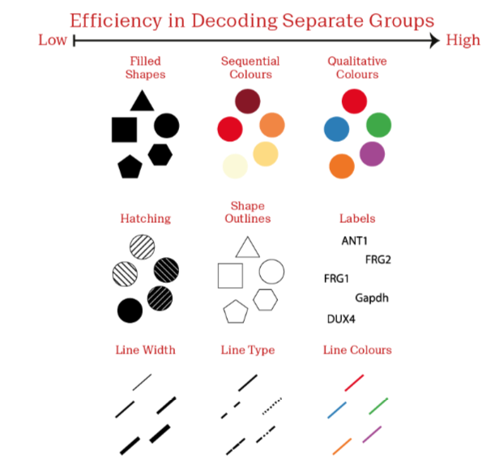

➡️ Let’s color the points in our scatter plot based on the species of the penguin being Adelie, Chinstrap, or Gentoo, reproducing the plot below.
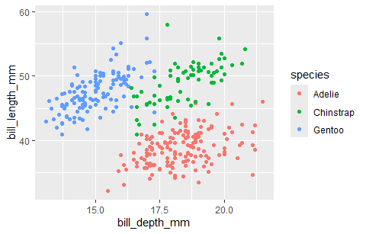
➡️ Next, add another layer to our ggplot to customize the title and subtitle using the labs() function to reproduce the plot below.
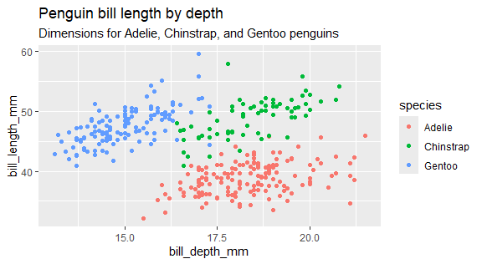

You try
➡️ Also customize the axis labels using the x and y options in the labs() function.
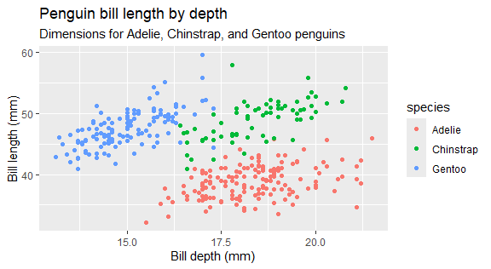
➡️ We can also customize the legend title by using the color option and a caption for the overall plot using the caption option in the labs() function. Customize the legend title to be “Species” instead of “species”, and modify the plot caption to match our overall desired plot.
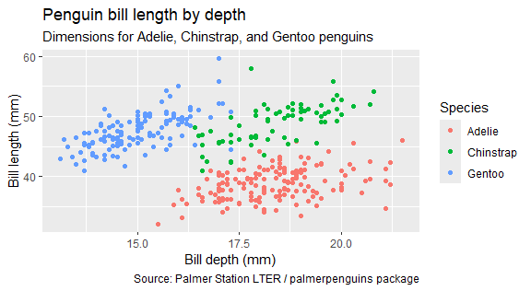
➡️ Lastly, use a discrete color scale that is inclusive of viewers with common forms of color blindness by adding a scale_color_viridis_d() layer to the plot, creating the final plot below.

Congrats! 🎨 🎉 🥳 You have now created a visualization using ggplot2!


Mapping vs. Setting
- Mapping in ggplot2 is the process of using aesthetics in a visualization to show additional variables from a data set. For example, in the plot below, body_mass_g is mapped to the size aesthetic.
ggplot(penguins,
aes(x = bill_depth_mm,
y = bill_length_mm,
size = body_mass_g)) +
geom_point()
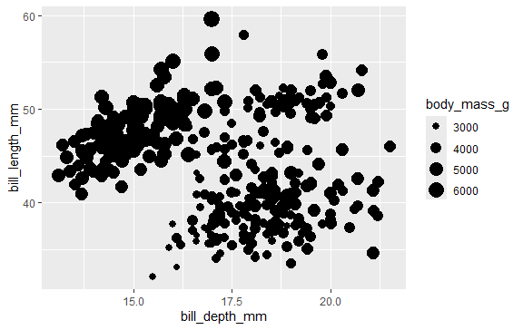
➡️ Reproduce the plot below by also mapping flipper_length_mm to the alpha aesthetic.
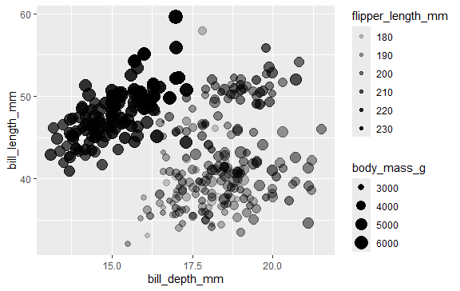
- Setting in ggplot2 is the process of manually specifying aesthetics for a visualization based on fixed values for all observations. In the visualization below, for example, the size aesthetic is set to a value of 2.
ggplot(penguins,
aes(x = bill_depth_mm,
y = bill_length_mm)) +
geom_point(size = 2)
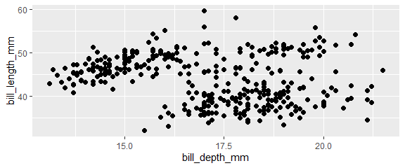
➡️ Reproduce the plot below by also setting the alpha aesthetic to be 0.50.
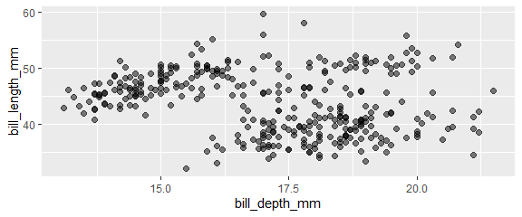
➡️ Is there any missing data? What is the plot doing with the missing values? Hint: consider using the skim() function from the skimr package to assess missingness.

Fundamental Visualizations
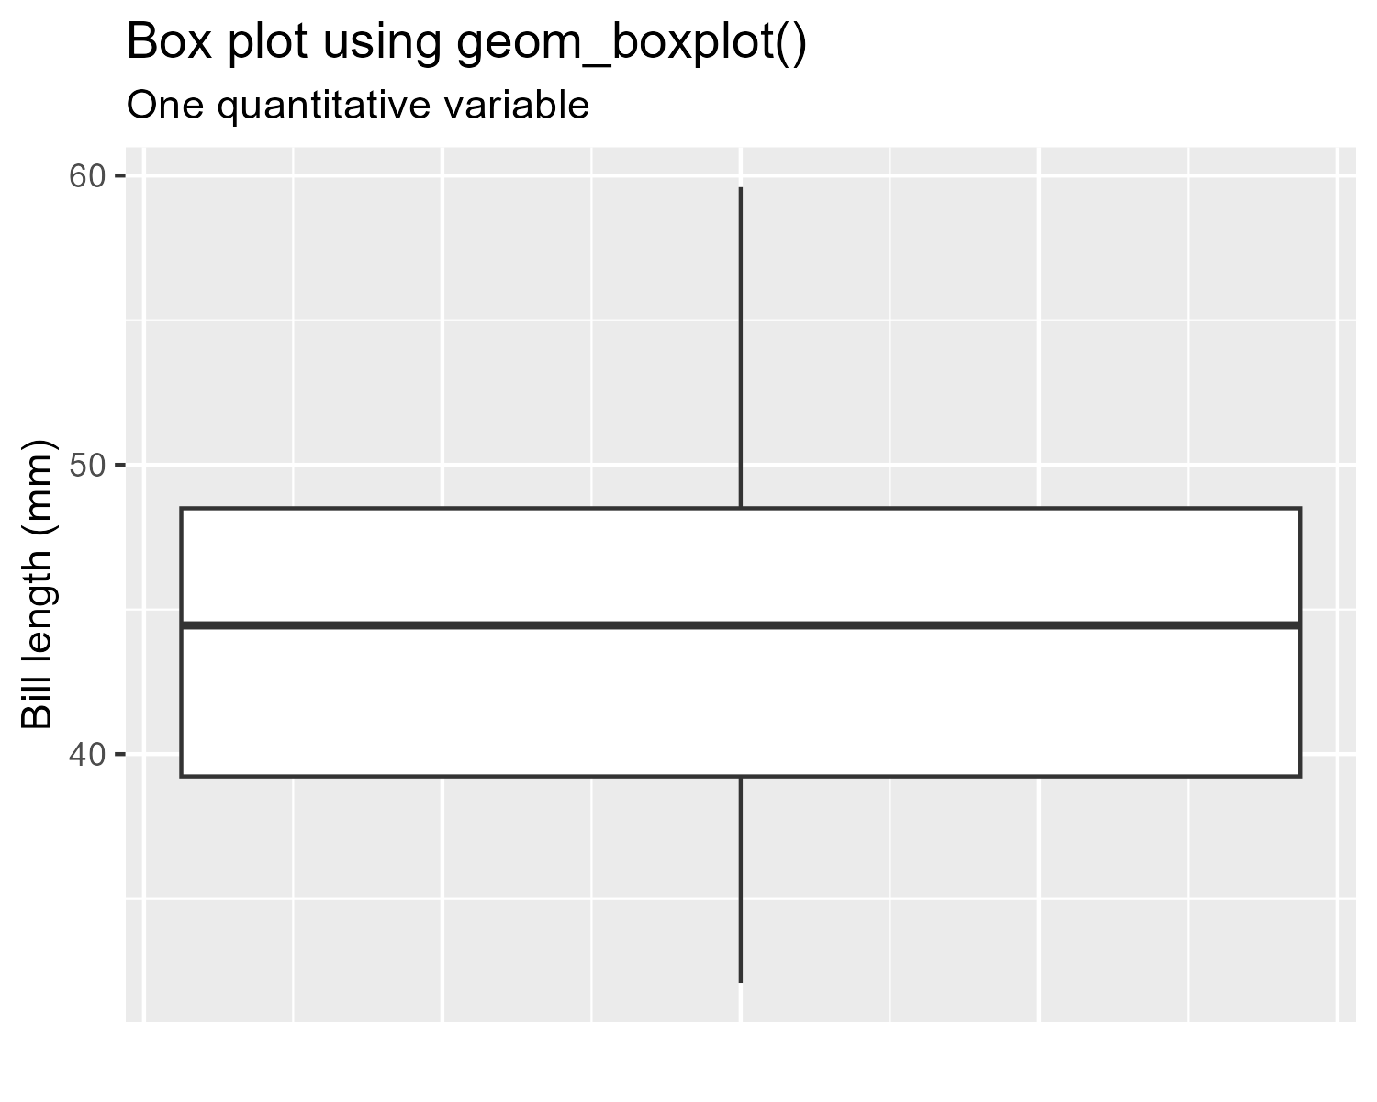 | 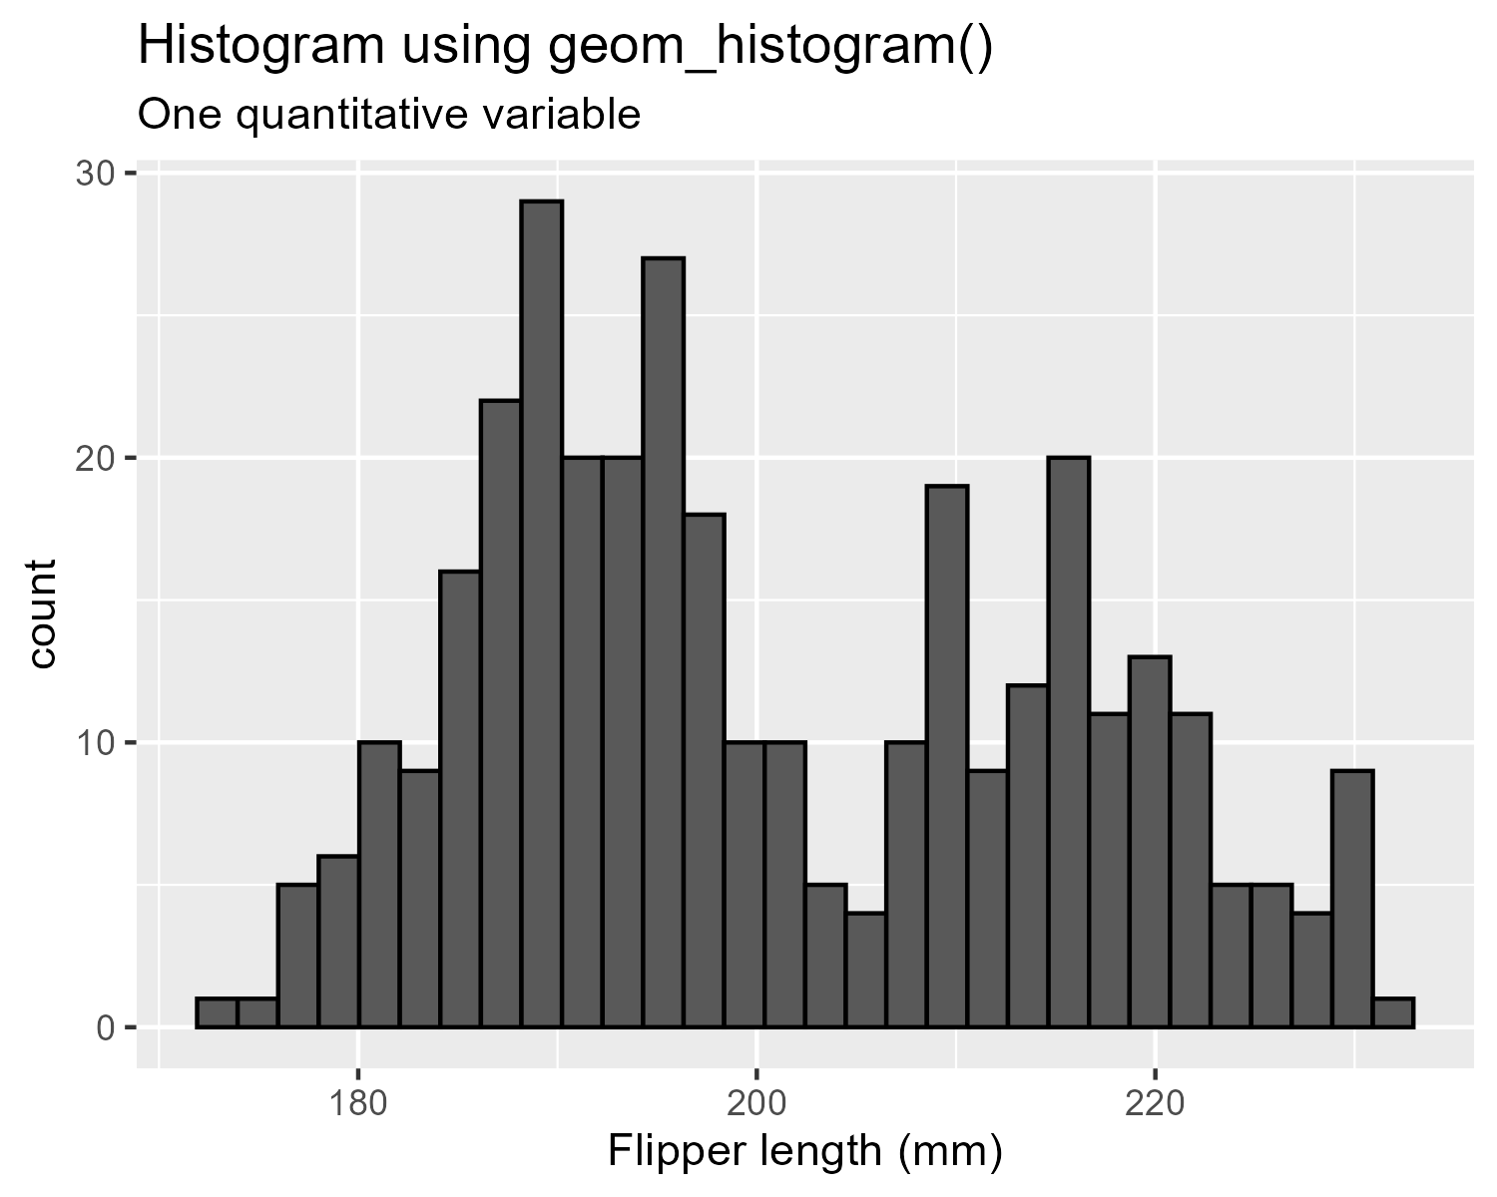
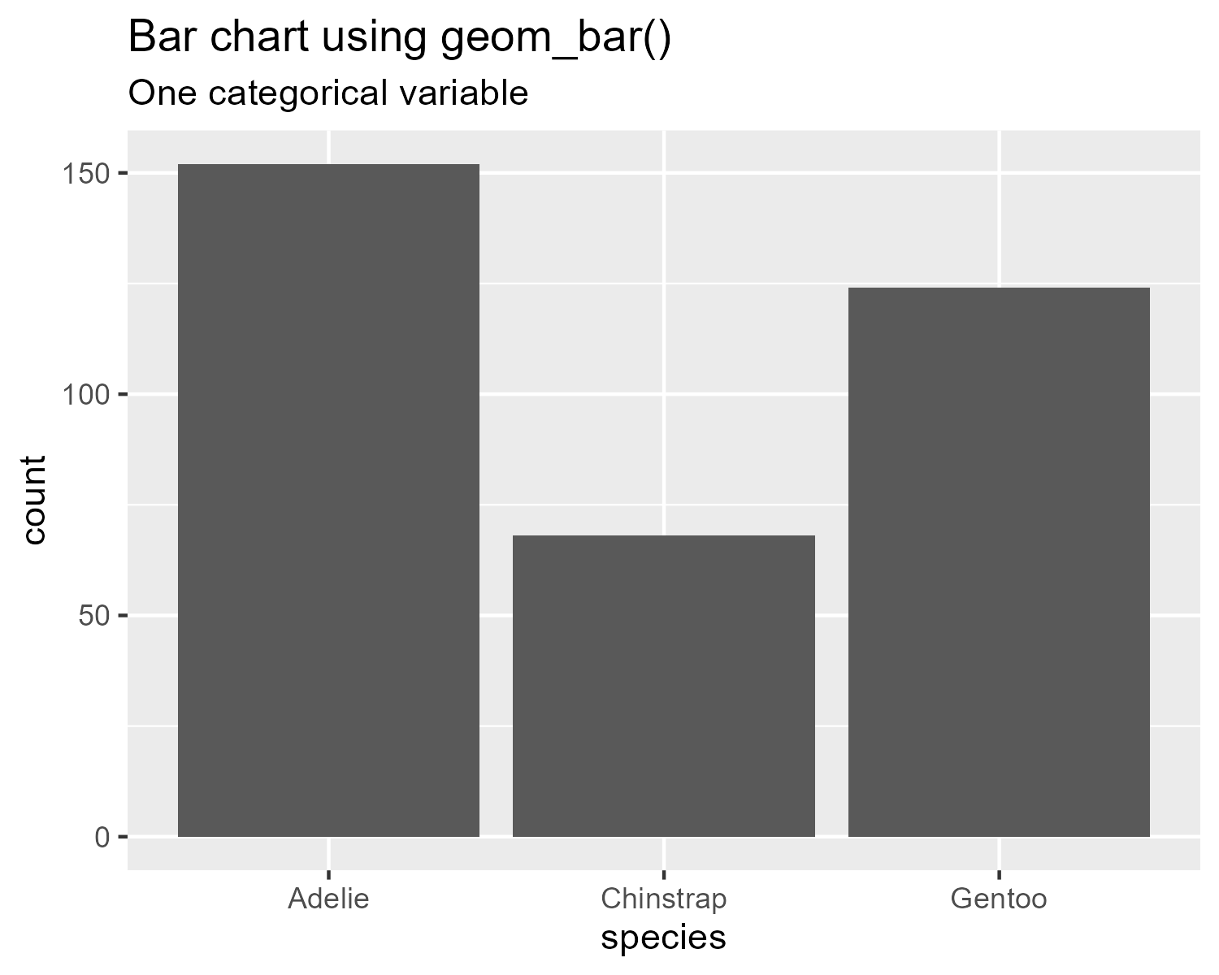 | 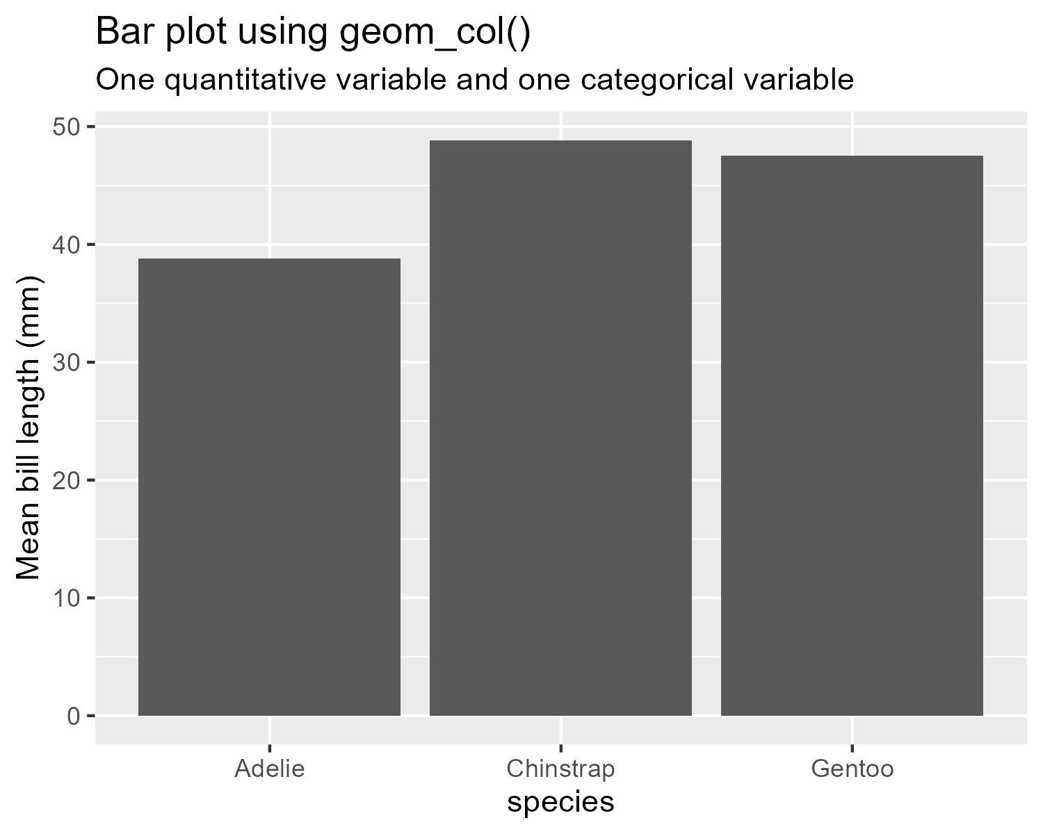
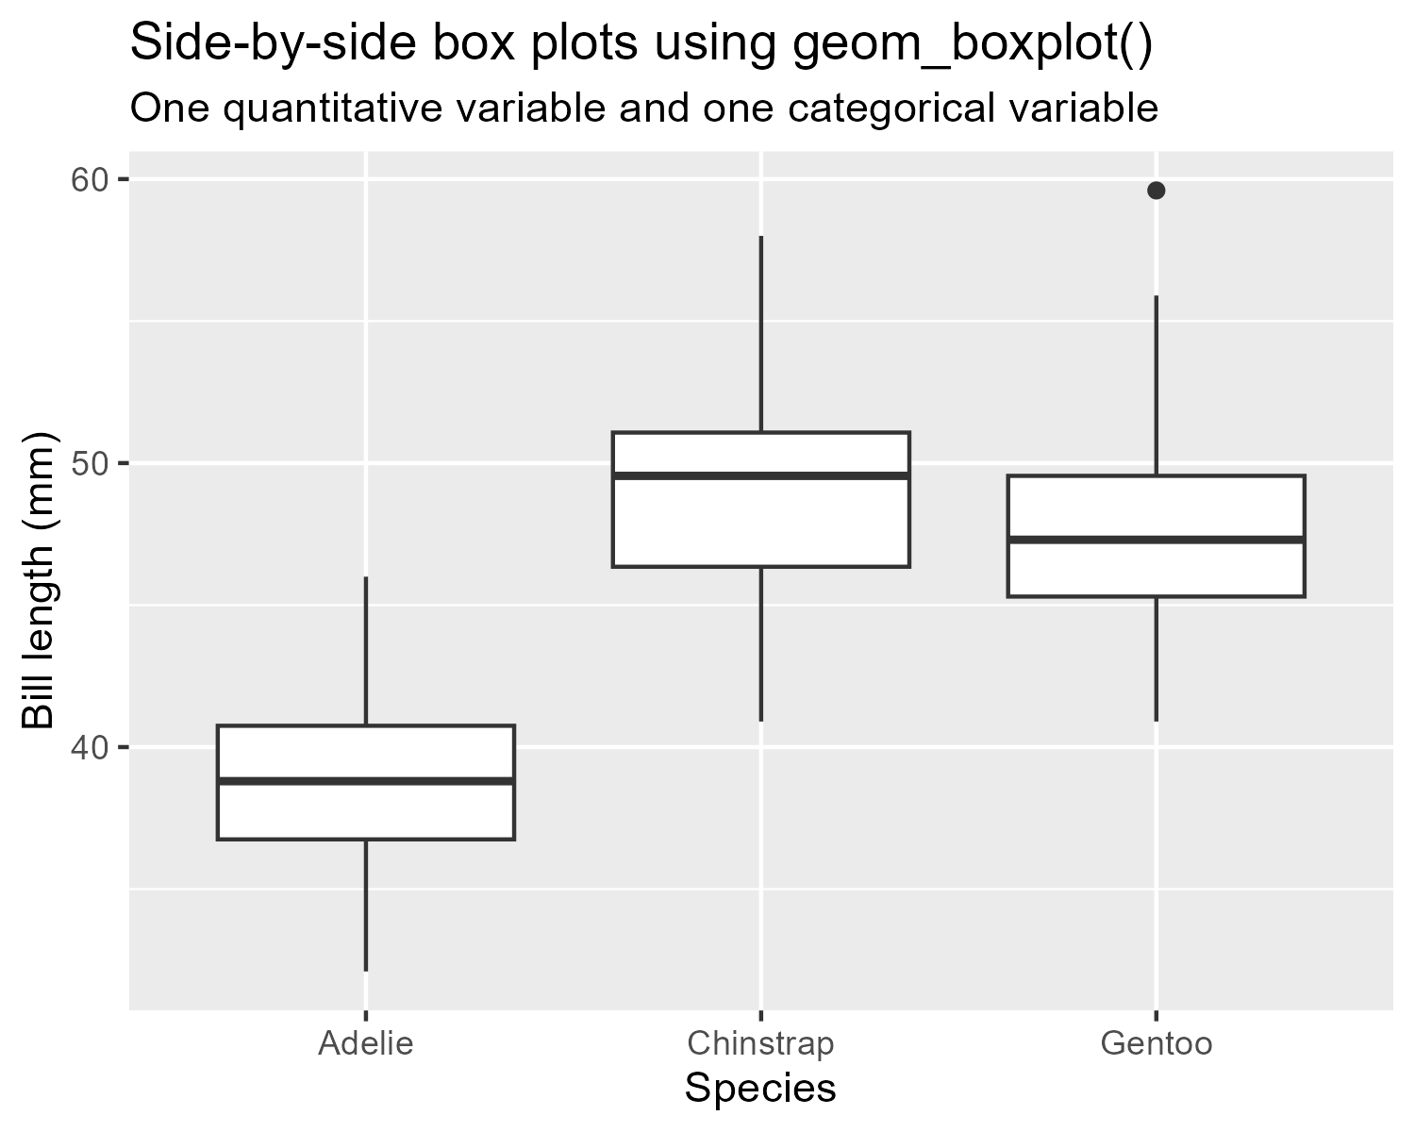 | 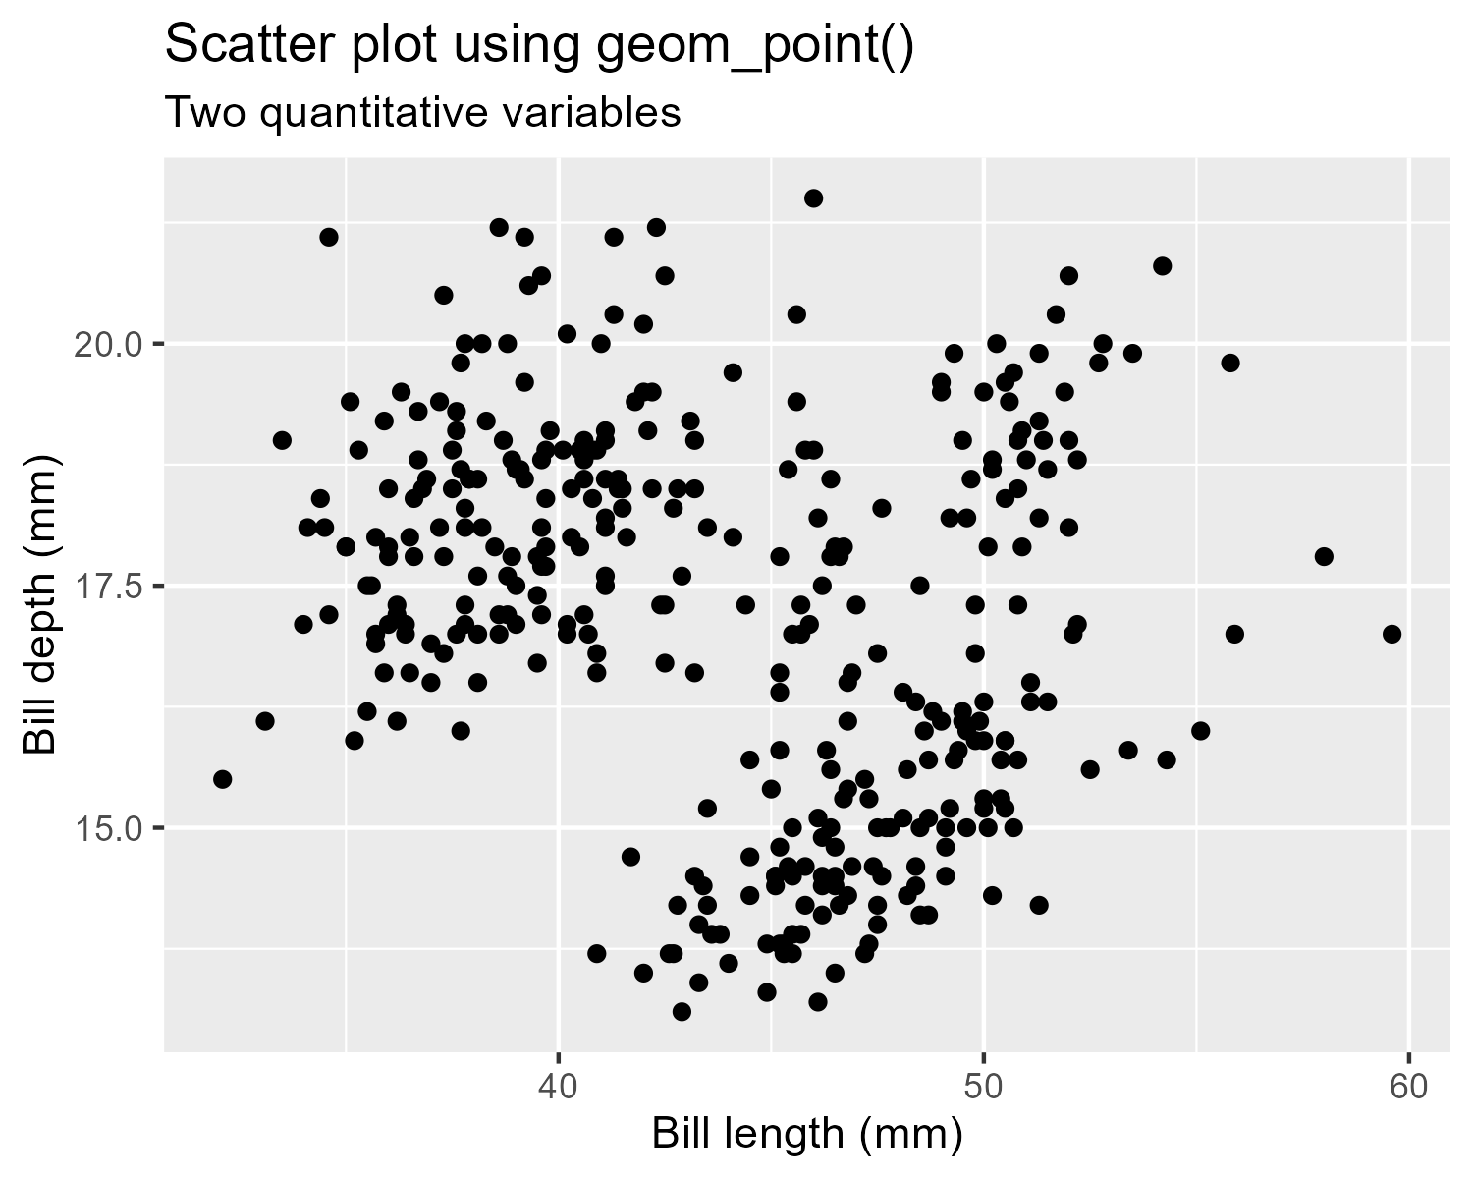

You try
➡️ Reproduce the histogram of the penguin body masses displayed below using ggplot2. Hint: we can control the outline color of the bars in the histogram using the color aesthetic.
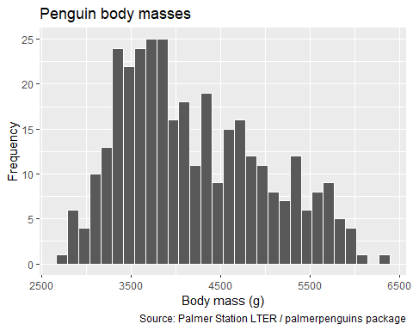
➡️ Reproduce the box plot of the penguin body masses displayed below using ggplot2. Hint: to suppress the y-axis text and ticks, add a theme(axis.text.y = element_blank(), axis.ticks.y = element_blank()) layer to the plot.
